Name: Rithik Sarvesh Bharathiraja

UID: 120395246 ([gbr2001@umd.edu](mailto:gbr2001@umd.edu))

Course: ENPM696

Task: In-class exercise 2

1. OS Name – Windows 10

Chrome version – 128.0.6613.120

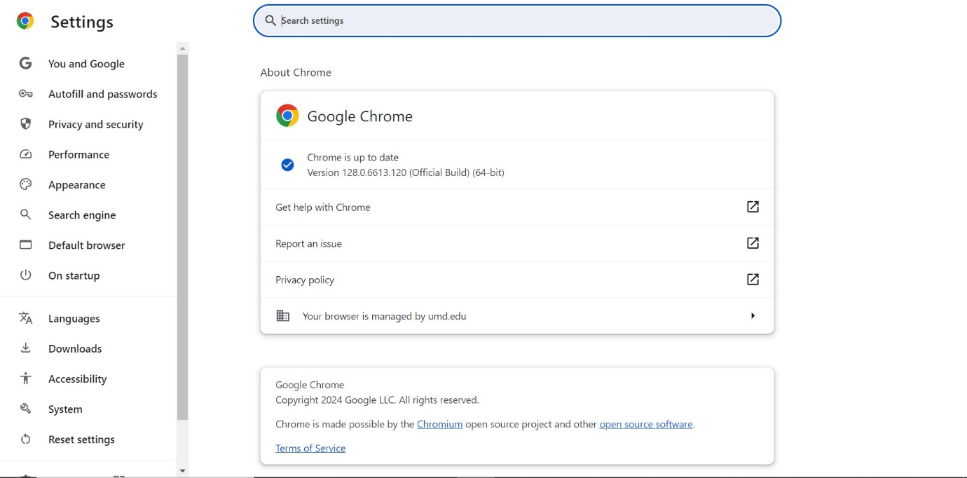

1. Process Explorer is being used for this exercise as it was given demo in the lecture and easy-to-use in Windows.

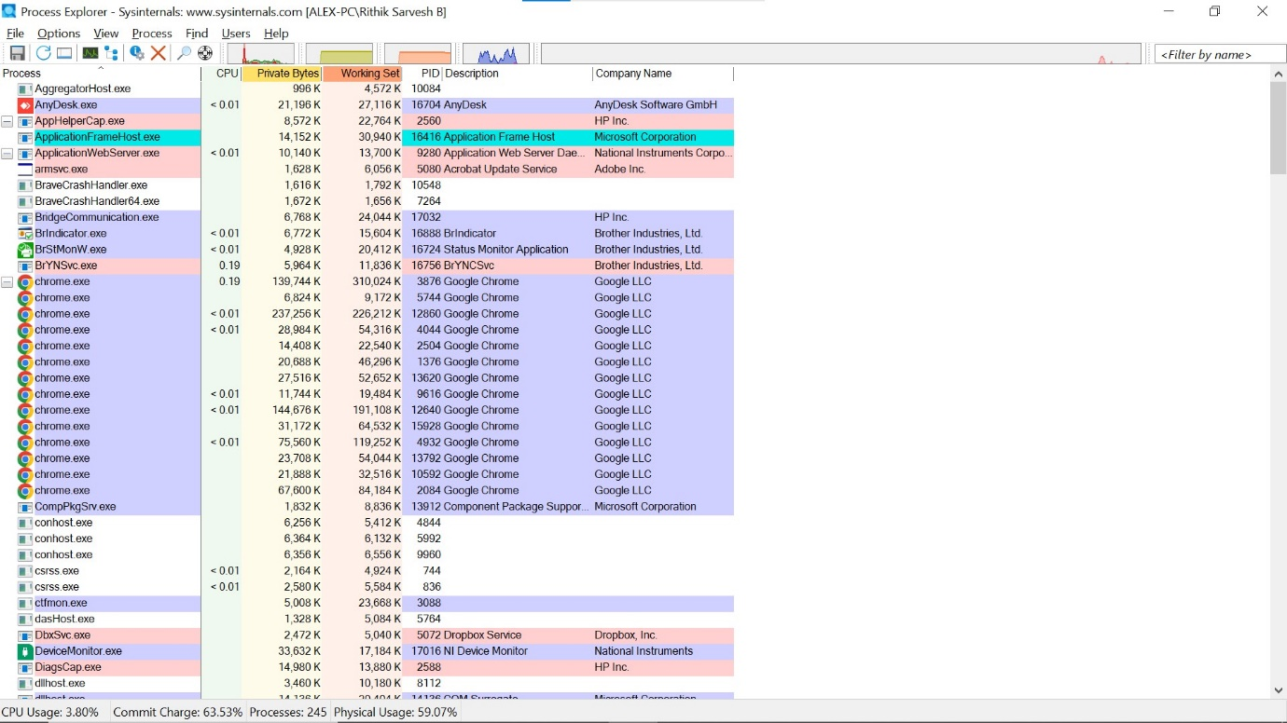

1. Just one chrome window is opened with just one tab.

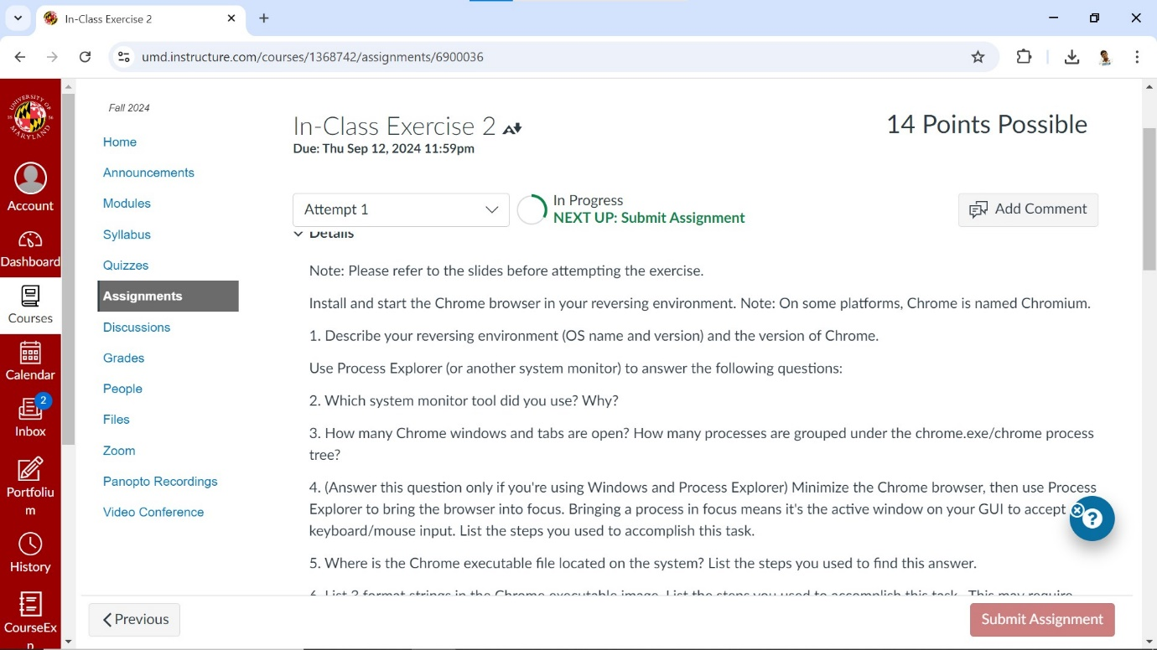

11 processes were running under the chrome process tree.

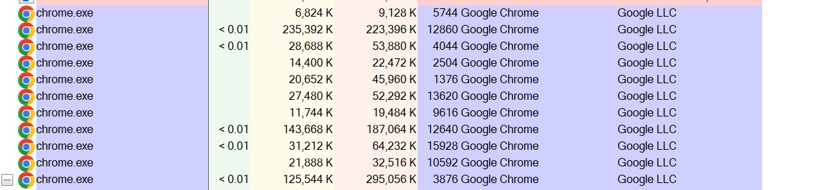

1. After double-clicking on a chrome process in the Process Explorer, Under “Image” tab, there is a feature called “Bring to front”. By clicking that, the browser is brought back to the focus.

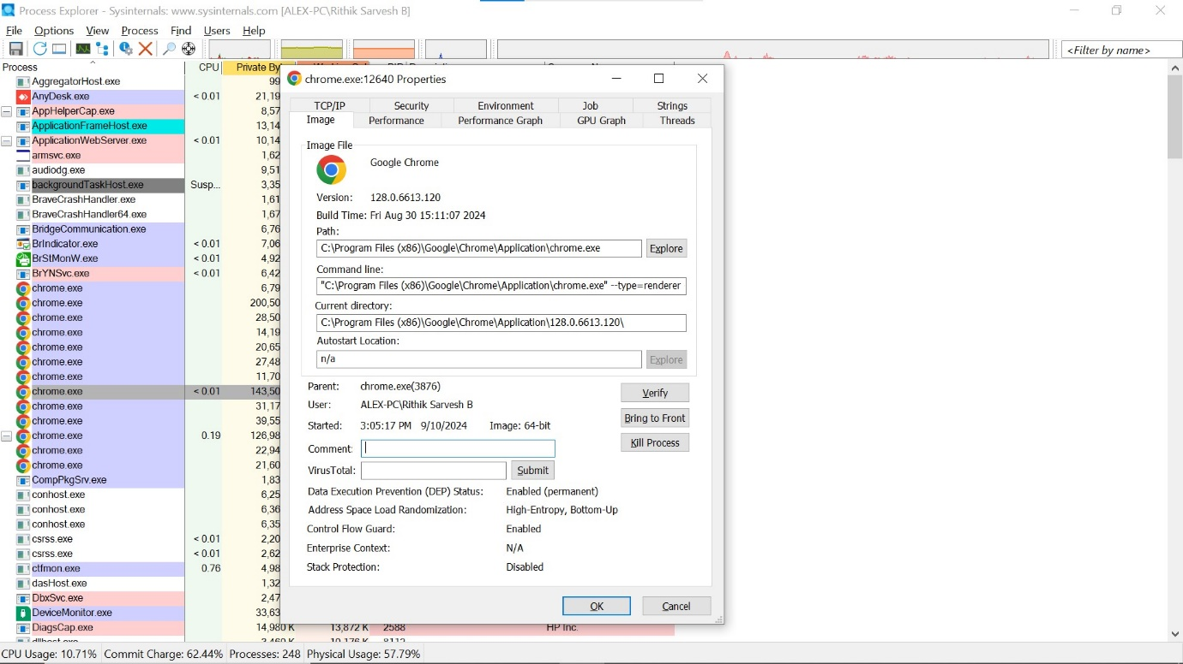

1. Chrome executable file is located in “C:/Program Files(x86)/Google/Chrome/Application”. After double-clicking on a chrome process in the Process Explorer, Under “Image” tab, the path of the chrome executable is given.

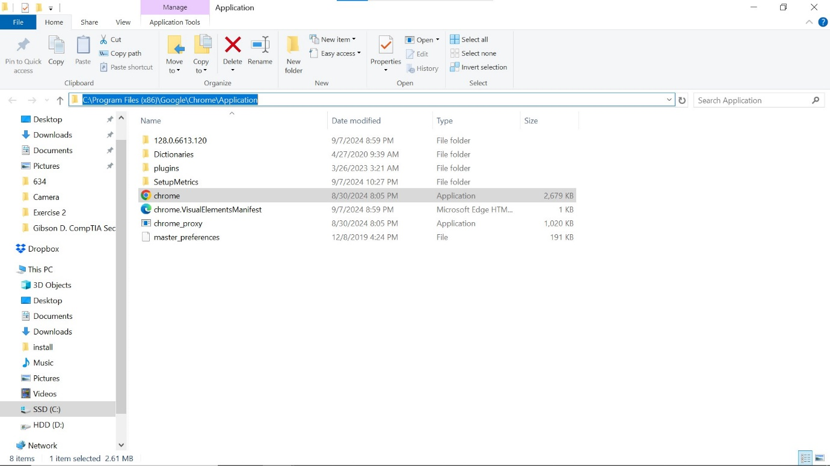

1. After double-clicking on a chrome process in the Process Explorer, under “Strings” tab, formatted strings in the executable are present. But, as I find most of them gibberish, I used Ubuntu strings and grep command to find meaningful strings.

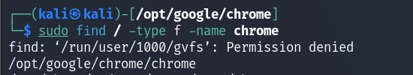

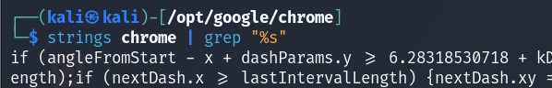

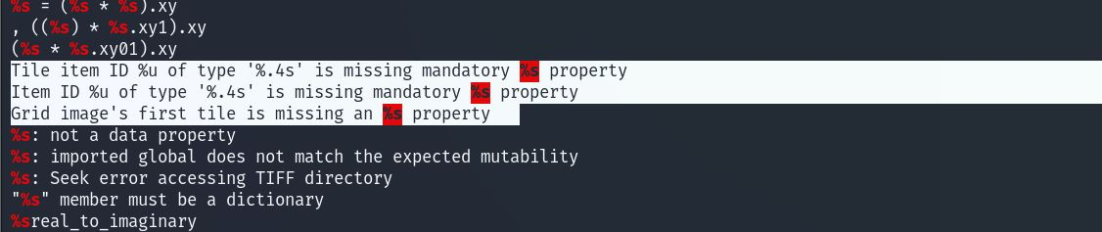

1. Under the “Environment” tab of the chrome process, location of the temporary data being written is mentioned.

Location – “C:/Users/RITHIK~1/AppData/Local/Temp”

